|  |  |  |  |
| --- | --- | --- | --- |
| ­ASSIGNMENT BRIEF | | | |
| **HTU Course No:** 40201341 **HTU Course Name:** Operating Systems  **BTEC UNIT No:** H/618/7486 **BTEC UNIT Name:** Operating Systems | | | |
|  | | | |
|  | |  | |
|  | | | |
| **Version: 1** |  | | |



# **Assignment Brief**

|  |  |
| --- | --- |
| Student Name/ID Number/Section |  |
| HTU Course Number and Title | 40201341 **Operating Systems** |
| BTEC Course Number and Title | H/618/7486 **Operating Systems** |
| Academic Year | 2022/2023 |
| Assignment Author | Nayef Abu-Ageel |
| Course Tutor | Nayef Abu-Ageel |
| Assignment Title | System Specialist |
| Assignment Ref No | Assignment 1 |
| Issue Date | 16/5/2023 |
| Formative Assessment dates | Every week until 1/06/2023 |
| Submission Date | Part 1: 18-6-2023 (11:59PM)  Part 2: 18-6-2023 (11:59PM) |
| IV Name & Date | Eng. Hana Al Rasheed – 16/5/2023 |

|  |
| --- |
| **Submission Format** |
| **Part 1 Project**  You are required to provide the following deliverables.   * **Project Report** * **Recorded Video:**   Upload a recorded video of Tasks 1-15 on YouTube and make sure to make it Publicly accessible or Unlisted sharing.   * **Oral Assessment of the Project**     **Part 2 Research**  You must submit a report that adheres to the below format and requirements.   * **Research Report** * **Oral Assessment of the Research**   Report format and requirements:  Submit two separate reports: one report for Part 1 and one for Part 2. Each report should:   * be submitted on <https://elearning.htu.edu.jo> * be written in a concise, formal business style using single spacing and font size 12. * make use of headings, paragraphs, and subsections as appropriate. * include screenshots and explanations for each of the tasks. * be referenced using the Harvard referencing system as needed. Provide a bibliography using the Harvard referencing system. * be word processed document, no handwriting will be accepted.   **You must sign and submit the declaration form.** |
| **Unit Learning Outcomes** |
| **LO1** Investigate different Operating Systems, their functions and user interfaces.  **LO2** Explore the processes managed by an Operating System.  **LO3** Demonstrate the use of DOS, Windows, UNIX and Linux.  **LO4** Analyse appropriate techniques and technologies used in distributed and concurrent systems. |
| **Assignment Brief and Guidance** |

**Part 1 Project**

OpSoft Inc. recently hired you as a system specialist within an administration team using the Red Hat Linux environment to manage the company’s operations. Your supervisor asked you to demonstrate common commands on different operating systems by doing the following tasks as part of your training:

1. **Create Server1 machine in Red Hat Linux Using a virtualization platform such as VMware, VirtualBox, or KVM.**

**Systems setup:**

**Hostname:** server1.tshoot.com

**Command -**> (hostnamectl set-hostname server1.tshoot.com)

**IP:** 192.168.1.150/24

**Gateway:** 192.168.1.1

**DNS:** 8.8.8.8

Command-> (nmcli con mod enp0s3 ipv4.method manual ipv4.address 192.168.1.150/24 ipv4.gateway 192.168.1.1 ipv4.dns 8.8.8.8)

**username:** root

**password:** HTU@2023

**Command:** (passwd root)

1. **The system time should be set to your time-zone and ensure that NTP sync in configured.**

**Command -> timedatectl set-timezone Asia/Amman -> for time zone**

**Command -> timedatectl set-ntp true -> for ntp sync**

1. **Repositories are available on the repo server at**:

**http://server1.tshoot.com/BaseOS**

**http://server1.tshoot.com /AppStream**

**Command:**

1. **Cd /etc/yum.repos.d/**
2. **vim baseos.repo**
3. **Add** [**http://server1.tshoot.com/BaseOS**](http://server1.tshoot.com/BaseOS)
4. **vim appstream.rep**
5. **add http://server1.tshoot.com /AppStream**
6. **check by using yum repolist**
7. **Make sure that the firewalld is enabled, if it is not enabled, activate it, and show the services dependent on the firewalld.**

**Command : systemctl is-enabled firewalld , systemctl is-active firewalld**

1. **Verify that client is using the network, IP, DNS & GW settings as mentioned above in the instructions. If not, then make necessary corrections.**

**Command:**

1. **Exit from root (exit)**
2. **From user use command (nmcli con show eno16777736 | grep -E 'IP4.ADDRESS|IP4.GATEWAY|IP4.DNS')**
3. **OR (ip addr show enp0s3),(cat etc/resolv.conf), and (ip route)**
4. **Add the following secondary IP Address statically to your currently running interface. It should be done in such a way that it doesn’t compromise your existing settings.**

IPv4 – 10.0.0.100/24

IPv6 - fd01::100/64

Command: nmcli con mod enp0s3 +ipv4.address 10.0.0.100/24

Nmcli con mod enp0s3 +ipv6.address fd01::100/64

1. **After installation is complete, explore the built-in help features:**

• Use man pages to research the fstab file. Command: man fstab

• What are the differences between the various man page sections? Admins primarily use sections 1, 5, and 8—why?

• Turn off the use of colors in the output of the ls command. After finding the relevant option, you need to save it to the /home/student/lscolor.txt text file.

1. **You are working on a server named "server1”:**

• Display the first 5 lines of the /etc/bin/sudoers send the output to the /home/student/headtail.txt file.

Command: mkdir /home/student

Head -5 /etc/sudoers > /home/student/headtail.txt

Cat /home/student/headtail.txt

• Additionally, you need to display the last nine lines of the same file and append the output to the /home/student/headtail.txt file.

Command: tail -9 /etc/sudoers > /home/student/headtail.txt

Cat /home/student/headtail.txt

1. **You will create individual directories for each department** **(sales, marketing, human resources, IT, engineering)** at the root of the filesystem in Red Hat Linux. Remember to execute the commands with administrative privileges to ensure successful directory creation. Command: mdkir /sales /marketing /human resources /IT /engineering
2. **Configure standard Linux** **permissions and ownership such that each group only has access to its own departmental directories**. For example, the sales group has access to the /sales directory but not to other departments' directories.

Command: chmod 770 /sales , marketing, human resources, IT, engineering

Groupadd sales , marketing, human resources, IT, engineering

Chown :sales /sales , :marketing /marketing, :humanresources /humanresouces ,

:IT /IT, :engineering /engineering

• After completing and testing the previous step, Configure sticky bit on the sales directory.

Command: chmod o+t /sales

• Create three files inside the sales directory called test1, test2, and test3 (command: touch /sales/test1,2,3), but make this directory a shared folder so that any user can access and modify his files. Make the IT directory and the whole sales directory read-only for the owner and the group.(command: chmod 440 /sales, IT) *set group id

1. **Create User Accounts and Assign Files:**

• Create user accounts for abeer, malak, mohamed, and ahmed.

command: **useradd** (abeer, malak, mohamed,ahmed) , **passwd** (abeer, malak,mohammed,ahmed)

• All user passwords should expire after 60 days and be set expire warning message before 3 days.

Command:

(passwd -x 60 abeer,malak,mohammad,ahmed)

Warning -> (chage -W 3 abeer,malak,mohammad,ahmed)

• Users abeer and malak should be in the “sales” group.

Command:

(usermod -G sales abeer, malak)

• Users mohamed & ahmed should be in the “IT” group.

Command: (Usermod -G IT Mohamed,ahmed)

• Set abeer as the owner of the /HR directory (chown abeer /humanresources) and restrict access to the /HR directory to only members of the HR group.->

Command: chmod 770 /humanresources

1. **Through the malak user, change the password of the abeer user.**

**Command:**

**1- su- malak**

**2- sudo passwd abeer -> change it from “abeer” to “password”**

1. **Determine the process using the most memory resources on server1 and terminate it.**

**Command: “top” -> the most memory use (%MEM) which is a process with PID= 2026 as shown below:**

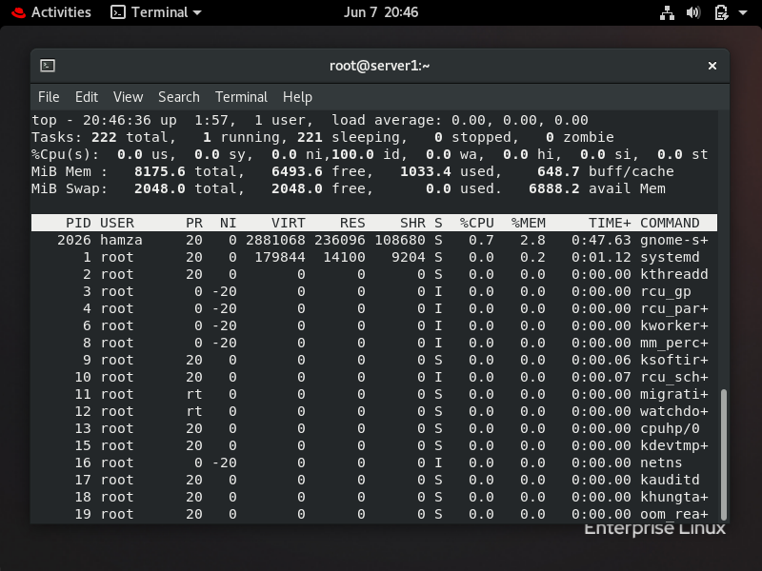

**2- kill 2026 , kill command by default come with ‘SIGTERM’ which is terminate.**

1. **Depending on vim, create four child process: file 1, file 2, file 3, and file 4, working in the background, after that, Kill the child process of file 3.**

**(from another terminal : using command pidof file.txt) -> get the UID and then kill the process. ) from the original window, should be terminated.**

1. **In the end , search for files with a size of more than 30 kilobytes in system.**

**Command: find / -type f -size +30k**

1. **Using Windows PowerShell, perform the following tasks:**
2. Create the following individual directories: sales, marketing, human resources, IT, engineeringat the root of the filesystem.
3. Create three files inside the sales directory called test1, test2, and test3.
4. Copy test1, test2, and test3 into the IT directory.
5. Write a script to get system date.
6. Create a text file called text1 in the marketing directory.

**Part 2 Research**

You are requested to do research on the following items:

1. Summarise what an operating system is and how it works with reference to different examples.
2. Research the evolution of operating systems.
3. Discuss the importance of operating systems.
4. Research the process of Memory Management in an Operating System.
5. Investigate the process of job scheduling. Include at least three scheduling algorithms.
6. Illustrate the importance of resource management in an operating system to aid its efficiency.
7. Analyze the security of different operating systems.
8. Explore the core features modern operating systems will require to meet future needs.
9. Assess how the features of modern operating systems will support the development of future needs such as automating common tasks based on user habits.
10. Evaluate the functionality, interface design and processes of a range of operating systems. Your evaluation should include mobile operating systems like Android and iOS equipped with AI-based voice assistants.
11. Evaluate the role of different operating systems in meeting the needs of future technologies and the implications on security. Examples of future technologies to consider include artificial intelligence and Internet of Things (IoT).
12. Describe how the Windows and Linux operating systems represent processes and threads. What resources are used when a thread is created? How do they differ from those used when a process is created?
13. Compare how different commands are carried out on different operating systems. Consider at least Linux and Windows operating systems.

[Different Operating Systems - GeeksforGeeks](https://www.geeksforgeeks.org/different-operating-systems/)

|  |  |  |
| --- | --- | --- |
| **Pass** | **Merit** | **Distinction** |
| **LO1 Investigate different Operating Systems, their functions and user interfaces.** | | **D1** Evaluate the functionality, interface design and processes of a range of operating systems. |
| **P1** Summarise what an operating system is and how it works with reference to different examples.  **P2** Research the evolution of operating systems. | **M1** Discuss the importance  of operating systems. |
| **LO2 Explore the processes managed by an Operating System** | |
| **P3** Research the process of Memory Management in an Operating System.  **P4** Investigate the process of job scheduling. | **M2** Illustrate the importance of resource management in an operating system to aid its efficiency. |
| **LO3 Demonstrate the use of different operating systems with a range of commands.** | | **D2** Evaluate the role of different operating system in meeting the needs of future technologies and the  implications on security. |
| **P5** Demonstrate common commands on different operating systems.  **P6** Compare how different commands are carried out on different operating systems. | **M3**  Analyse the security of  different operating systems. |
| **L04 Examine how operating systems will function in the future and the implications on security.** | |
| **P7** Explore the core features modern operating  systems will require to meet future needs. | **M4** Assess how the features of modern operating systems will support the development of future needs. |

**Assessment Criteria**

**Student Assessment Submission and**

**Declaration**

When submitting evidence for assessment, each student must sign a declaration confirming that the work is their own.

|  |  |  |  |
| --- | --- | --- | --- |
| **Student name:** | | **Assessor name:** Nayef Abu-Ageel | |
| **Issue date:**  May 16, 2023 | **Submission date:**  18-6-2023 (11:59PM) | | **Submitted on:** |
| **Programme:** Computing | | | |
| **Course Name: Operating System**  **HTU Course Code:** 40201341  **BTEC UNIT:** 50 | | | |
| Assignment number and title:  No. 1: System Specialist | | | |

**Plagiarism**

Plagiarism is a particular form of cheating. Plagiarism must be avoided at all costs and students who break the rules, however innocently, may be penalized. It is your responsibility to ensure that you understand correct referencing practices. As a university-level student, you are expected to use appropriate references throughout and keep carefully detailed notes of all your sources of materials for the material you have used in your work, including any material downloaded from the Internet. Please consult the relevant unit lecturer or your course tutor if you need any further advice.

|  |
| --- |
| **Student declaration**  I certify that the assignment submission is entirely my own work and I fully understand the consequences of plagiarism. I understand that making a false declaration is a form of malpractice.  **Student signature: Date:** |